**INFOSYS MILESTONE-2**

**Milestone 2 – Infosys Internship**

**TOPIC: Students Performance Factors using Power BI**

**Introduction:**

The dataset contains 6607 records detailing various factors influencing student performance. It includes attributes like study habits (e.g., hours studied, attendance), personal aspects (e.g., sleep hours, physical activity), environmental factors (e.g., parental involvement, family income, access to resources), and academic settings (e.g., school type, teacher quality, peer influence). Key outcomes like previous scores and current exam scores are provided to analyze performance trends. Additionally, demographic details like gender, parental education, and distance from school are included, offering a comprehensive view of the elements impacting academic success.

**Understanding Relationships in Power BI:**

To create meaningful reports and charts from the provided data, we need to establish relationships between the tables based on the data structure. Here’s a breakdown of the *relationships* used:

Primary Key & Relationships

1. Primary Key: Student_ID is the unique identifier for each student in all three tables: Student_Demographics, Academic_Info, and Personal_Factors.

2. Relationships:

- One-to-One Relationship between the tables:

- Student_Demographics [Student_ID] ↔ Academic_Info [Student_ID]

- Student_Demographics [Student_ID] ↔ Personal_Factors [Student_ID]

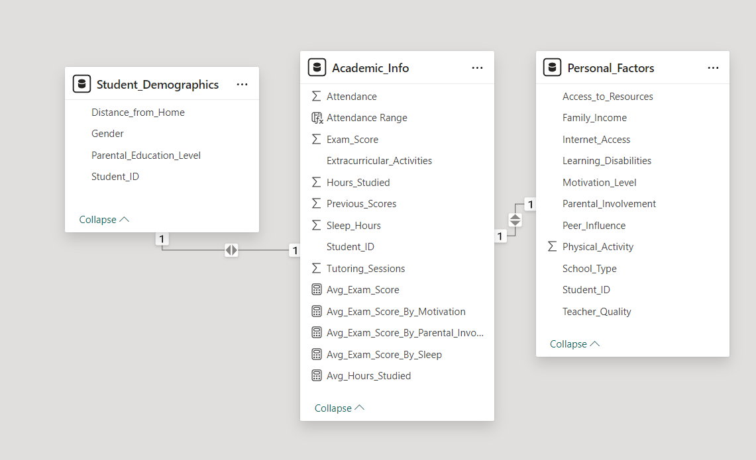

**Report 1: Academic Info Analysis**

This report analyzes the academic performance and habits of students based on data from the Academic_Info table. It focuses on understanding how various factors such as study hours, attendance, previous scores, tutoring sessions, and extracurricular activities influence exam scores.

1. Academic Performance Analysis

Chart: Average Exam Score by Hours Studied Range

DAX Measure

- Create a measure for Average Exam Score and group students into study hour ranges (e.g., 0-10, 10-20).

- Example:

DAX:

Avg_Exam_Score = AVERAGE('Academic_Info'[Exam_Score])

Visualization;

Chart Type: Clustered Column Chart

X - Axis: Study Hour Ranges

Y - Axis: Average Exam Score

2. Demographic Insights

Chart: Distribution of Students by Parental Education Level*

DAX Measure

- Count students based on Parental_Education_Level.

- Example:

DAX

Student_Count = COUNTROWS('Student_Demographics')

Visualization;

- Chart Type: Pie Chart

- Categories: Parental Education Levels

- Values: Student Count

3. Personal Factor Impacts

Chart: Exam Scores by Motivation Level and Parental Involvement*

DAX Measure

- Create an average exam score for each motivation and parental involvement level.

- Example:

DAX

Avg_Exam_Score_By_Motivation=CALCULATE(AVERAGE('Academic_Info'[Exam_Score]), ALLEXCEPT('Personal_Factors','Personal_Factors'[Motivation_Level],'Personal_Factors'[Parental_Involvement])

Visualization;

Chart Type: Stacked Bar Chart

X - Axis: Motivation Level

Legend: Parental Involvement

Y - Axis: Average Exam Score

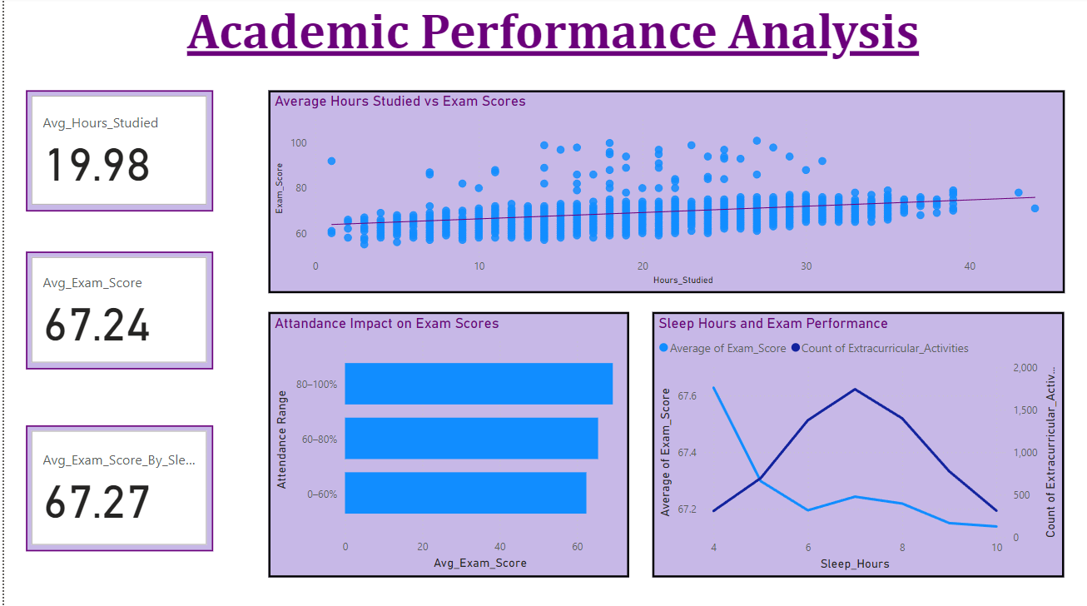

**Report Image 2: Demographics and Performance**

This report explores the impact of *gender* and *parental education level* on student *exam scores*, aiming to identify patterns or trends that could guide interventions and support strategies.

1. Gender Influence: The column chart reveals a difference in average exam scores between males and females. However, the magnitude of this difference and its statistical significance are unclear.

2. Parental Education Impact: The bar chart or stacked column chart shows a relationship between parental education levels and student exam scores. Students with parents having higher education levels tend to perform better.

1. Gender vs. Exam Scores

Purpose: Determine whether gender influences academic performance.

-Visualization:

- Column Chart:

- X-axis = Gender (Male, Female).

- Y-axis = Average Exam Score.

- Add a slicer for ‘School Type’ to observe variations across educational environments.

- DAX Function:

DAX

Avg_Exam_Score_By_Gender =

CALCULATE (

AVERAGE (Academic_Info [Exam_Score]),

Student_Demographics [Gender]

)

2. Parental Education Level vs. Exam Scores

Purpose: Assess how parents' education levels influence student performance.

- Visualization

- Stacked Column Chart:

- X-axis = Parental Education Levels (e.g., High School, Bachelor's, Master's).

- Y-axis = Average Exam Score.

- Series = Gender (optional, to show male vs. female performance for each education level).

- DAX Function:

Avg_Exam_Score_By_Parental_Education =

CALCULATE (

AVERAGE (Academic_Info [Exam_Score]),

Student_Demographics [Parental_Education_Level])

3. Combined Analysis: Gender and Parental Education Level

Purpose: Explore the combined impact of gender and parental education on exam scores.

- Visualization

- Matrix:

- Rows = Parental Education Levels.

- Columns = Gender.

- Values = Average Exam Score.

- DAX Function:

Avg_Exam_Score_Combined =

AVERAGE (

SUMMARIZE (

Student_Demographics,

Student_Demographics [Gender],

Student_Demographics [Parental_Education_Level],

"Avg_Score", AVERAGE (Academic_Info [Exam_Score])

),

[Avg_Score]

)

4. Exam Scores Distribution by Gender

Purpose: Visualize the spread of scores for males and females.

- Visualization

- Box Plot:

- X-axis = Gender.

- Y-axis = Exam Scores.

- Tooltip = Display metrics like attendance or study hours for each gender.

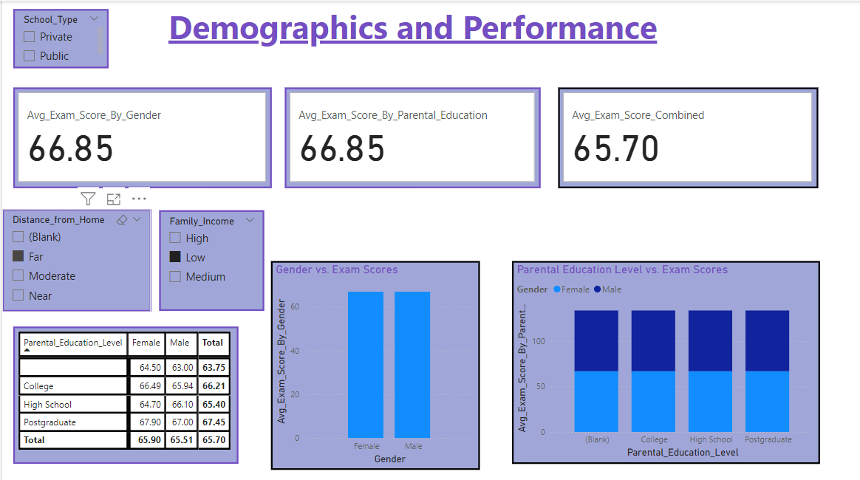

REPORT 3: Student Performance

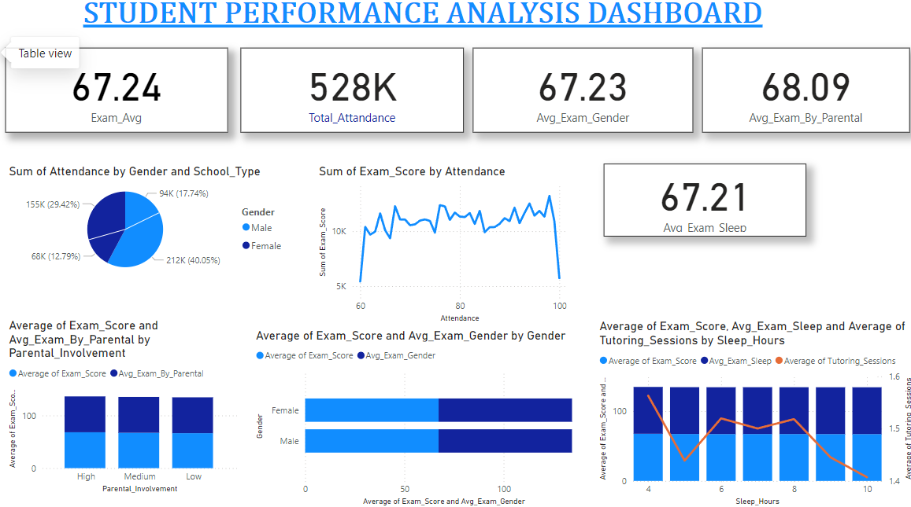

**Conclusion:**

The "Student Performance Dashboard" provides valuable insights into how various factors-like study habits, attendance, motivation, and parental involvement-impact student exam scores. By using DAX calculations, the dashboard effectively highlights patterns and relationships within the data, enabling educators and administrators to identify key areas for intervention. This tool serves as a powerful resource for understanding the dynamics behind academic success and supporting data-driven decisions to improve student outcomes